Themed Event: Flood Risk / Évènement thématique : Risque des inondations

10th July 2019 /
10 juillet 2019

London, England /
Londres, Angleterre

Venue / Lieu
The Wesley Euston Hotel & Conference Venue
81-103 Euston Street
Kings Cross, London NW1 2EZ
+ 44 (0) 207 691 8512
https://www.thewesley.co.uk/contact

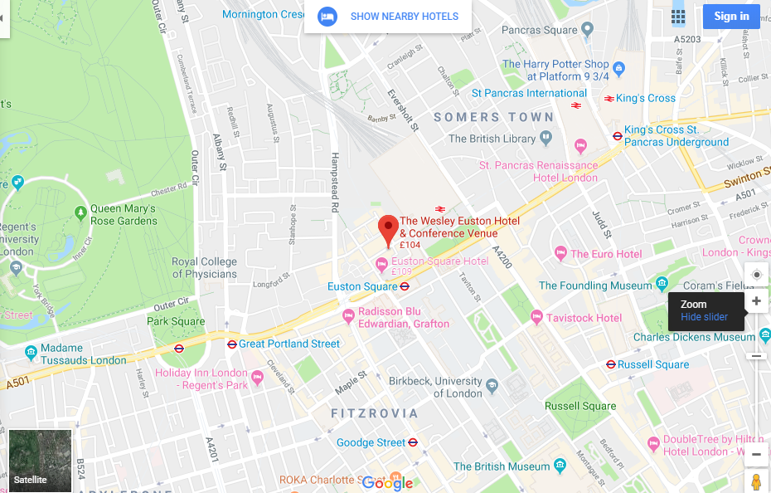

Online map / Carte en ligne : https://goo.gl/maps/CnG1p7UdhAH3Ec2j7

Public transport nearby  - Nearest Underground: Euston Square – 0.1mile  - St Pancras International – 0.8 mile  - Kings Cross Train Station -0.8 mile | Airports nearby  - London Heathrow Airport- 14 miles  - London Gatwick Airport – 29 miles  - London City Airport -9 miles  - London Stansted Airport -35 miles  - London Luton Airport – 30 miles

Transport public à proximité  - Métro le plus proche : Euston Square – 0.1mile  - St Pancras International – 0.8 mile  - Kings Cross Train Station -0.8 mile | Aéroports à proximité  - London Heathrow Airport- 14 miles  - London Gatwick Airport – 29 miles  - London City Airport -9 miles  - London Stansted Airport -35 miles  - London Luton Airport – 30 miles

